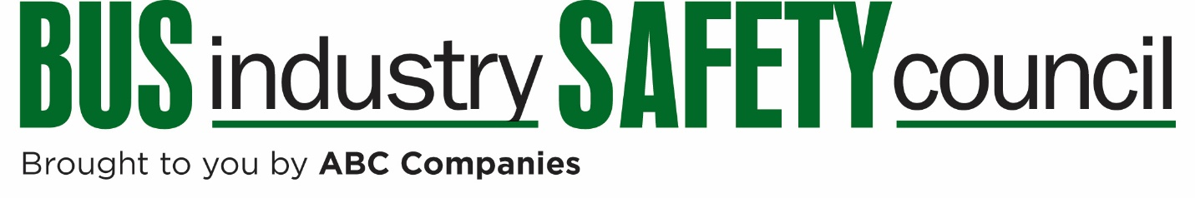
BISC Human Performance Committee
Meeting Agenda
May 11, 2017
10:00 AM ET
Chair  Rick Vaillancourt  Cyr Bus Lines  Old Town, ME  rick.v@cyrbustours.com | Vice Chair  Rocky Bewley  Miller Transportation  Louisville, KY  rocky@millertransportation.com
To Access the Call:
Dial: (800) 220-9875
Passcode: 37191286
Discussion Topics
- Hair Follicle Drug Testing Update
- Drug & Alcohol Clearinghouse
- Entry Level Driver Training – FMCSA Beta Testing
- Driver Credentialing Issues – Airports, Ports, School Districts
- Sleep Apnea ANPRM Update
- 2017 Summer Meeting Preview

Topics for future meetings?

