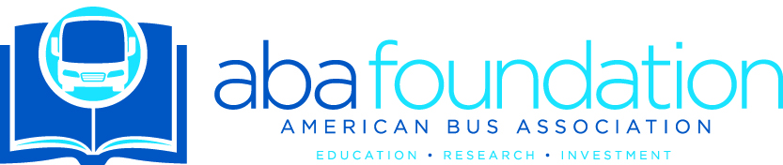
ABA Foundation 2024 Auction Donation
Thank you for your interest in donating to the ABA Foundation’s 2024 Silent Auction! Please complete this form and return to mhinton@buses.org by email.
* Required
Email address *

Organization *

Contact Name *

Phone Number*:

Address:

City:

State/Province:

Zip Code:

Website*:

Name of Package or Item *

Description of Package or Item *

Donation Value* (Note donation value for the Silent Auction must be at least $250)

Is there an expiration? If so, please include the date.

Is delivery to the auction winner included in your donation? *
□Yes □No □Not Applicable
□Other:

Please list conditions of use, restrictions, exclusions, or blackout dates. If you do not list any restrictions, the package or item will be listed with no restrictions.

Is there anything else we or the auction winner needs to know?

Please attach any other information that is necessary for your item.
Please email an image of the donated item and your company logo to mhinton@buses.org.
IMPORTANT! In partnership with Bidding For Good, the ABA Foundation is expanding the reach of our auction by making items accessible to the Bidding For Good Bidder Community. Once the auction opens, the Bidding For Good Bidder Community will be able to bid on items.
If you do not want your donated item available outside of the ABA membership, please check here.

Instead of donating an item, I would like to make a cash donation of $________. Please make your check out to The American Bus Association Foundation Scholarship Program.

Thank you! Your donations go to support the future of our industry. We are adding two additional scholarships this year to raise the number we give out to 23. Your generosity helps to make this happen.

