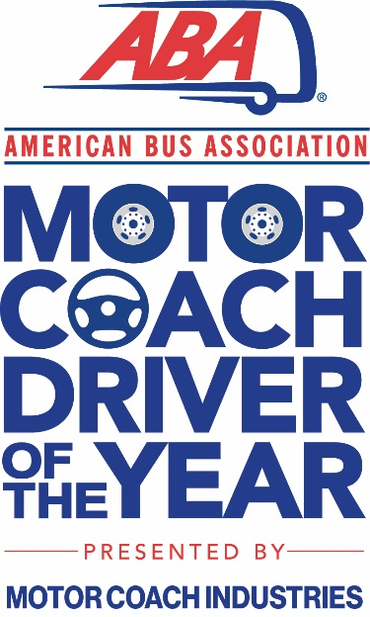
American Bus Association Motorcoach Driver of the Year
The purpose of the ABA Motorcoach Driver of the Year Award is to recognize an individual who has gone above and beyond the performance of his or her duties as an Over Road Motorcoach Driver, professionally executing safe motorcoach operation, while providing the traveling public with the safest form of passenger transportation in the United States.
The procedure for nominating an applicant for the award includes completing the application with the required documents by December 1, 2023. The applicant must meet all of the criteria set forth as described below. The award will be announced at the 2024 ABA Marketplace.
Award Criteria:
- The Nominee must be employed as an over-the-road motorcoach driver by an ABA Member (full- or part-time).
- The Nominee must have a minimum of ten (10) years cumulative experience driving an over-the-road motorcoach.
- The Nominee must not have any felony convictions.
- The Nominee must not have any driving violations in the past three (3) years, excluding form and manner violations.
- The Nominee must not have had a chargeable accident for a minimum of ten years. Non-chargeable incidents or incidental accidents (bumpers, mirrors) do not count.
The supporting documentation required is a three (3) year history of the nominee’s motor vehicle record (MVR) and customer testimonial letters on behalf of the nominee.
Please note that permission must first be received from the nominee before sharing their MVR.
Nominee information:
Name:
Company:
Company Address:
Nominator information:
Name:
Title:
Relationship to Nominee:
Company:
Company Address:
Phone Number:
Email:
Nominee’s Driving Record
Type of Driver: Charter/Tour______, Commuter ______, Intercity/Schedule______, Other_______
Total number of years driving an over-the-road motorcoach: _______
Number of years driving an over-the-road motorcoach at his or her current company: __________
Estimated accident free miles driving an over-the-road motorcoach in the past 12 months: __________
Estimated total miles driving an over-the-road motorcoach (if available) _________
Awards:
Has the nominee received any company safety awards? If yes, please describe the award(s).
Has the nominee received any other awards or recognition as a result of their driving experience or company service? If yes, please describe the award(s).
Additional Information:
Has the nominee participated in any community involvement activities (e.g. volunteering)? If yes, please describe the involvement.
Has the nominee participated in any industry-related activities (e.g. rodeos)? If yes, please describe the involvement.
Is the nominee a driver instructor or assisted other drivers with driver training? If yes, please explain the nominee’s involvement.
Nomination Statement for Consideration:
Provide a written explanation as to why the nominee should be considered for the Motorcoach Driver of the Year Award. Describe how the nominee has gone above and beyond the performance of his or her duties as an over-the-road motorcoach driver, professionally executing safe motorcoach operation, while providing the traveling public with the safest form of passenger transportation in the United States.
Statement of Truth from the Nominator
By signing below, you are acknowledging the facts and information provided are true and accurate.

Signature Date

