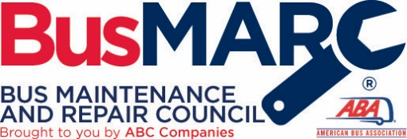

BISC/BusMARC – Buying a Bus
Moderator Questions

How to buy a bus

1. What’s new and exciting that you are offering?

2. When considering a new bus what “amenities” do you find to be the most popular?

3. What do you find the least popular amenities, but maybe considered the most important?

4. Any unusual stories about buying a bus?

5. From a graphics perspective, how long does it take to get graphics?

6. Should you accept delivery of a bus without graphics?

7. Should you have multiple inverters? If so why?

8. What are the thoughts on alternators…. Are there any new recommendations?

9. From an A/C compressor perspective what’s new?

10. What’s new with lighting?

11. What type of seat options do you have and what do you recommend?

12. I want satellite tv installed who should do that. If I’m going to have it installed, should I ask for anything extra to be ready for the install?

13. What’s lead time expected to be in a new coach?

14. Any special inspection that should take place before you accept delivery? Who should do this inspection?

