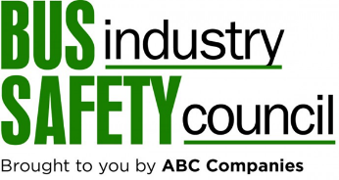

BISC – Training for Motorcoach Emergencies
Moderator Questions

- What are the most common emergencies that happen to or onboard motorcoaches?
- How and when do you prepare your drivers and staff for these emergencies?
- What kinds of things can you do to help prepare passengers for these kinds of emergencies? Do you add additional information to the passenger safety message for example?
- Are there any specialty items or special equipment that you equip your buses with before trips? How often do you change out or inspect these items? Who is responsible to check the status of these items?
- Where might you source or brainstorm new emergencies to consider for training? Study accident reports, casual conversation at conferences like these, insurance meetings?
- How do you evaluate responses to emergencies? Who does this for you?
- Is there an emergency that motorcoach operators tend to collectively respond best to generally speaking? Why is that?
- What’s the best way to practice for emergencies? Tabletop exercise, live simulation, workflow diagram, role playing?

