MENTOR REQUEST 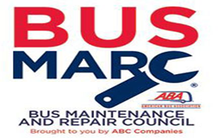

Name ______________________________________ Company ______________________________
Current Position(s) ___________________________________________________________________
Preferred email address _________________________Preferred phone number _________________
Location(s) of your Company ___________________________________________________________
I am seeking a mentor to help me with:
____ Regulations and Compliance ____ Administrative Functions (reports, documentation)
____ Driver Training ____ Vehicle Maintenance
____ General Operations ____ Hiring and Recruiting
____ Human Resources ____ Retention of Employees
____ OSHA Training ____ Location and Vehicle Security
____ Other (please specify) ____________________________________________________________

What are your current challenges? _______________________________________________________

Received by _______________________________ Date _________________
Applicant notified __________________________ Date _________________
Mentor Assigned ___________________________ Date _________________
Mentor First Contact ________________________ Date _________________
All information provided under this mentor program is intended as guidance and is not a legal interpretation of any federal, state, or local laws, rules, or regulations applicable to your business. The ABA and each participating mentor expressly disclaims all liability to the fullest extent of the law with respect to actions taken or not taken based on information provided as part of the mentor program.

