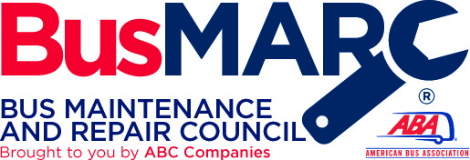

BusMARC – Creative Solutions to Battling Supply Chain Issues, Finding Needed Parts
Moderator Questions

1. How much of a challenge is downtime in most fleets?
2. What do you find to be the leading cause of downtime?
3. How many/value of parts do you recommend companies keep in their inventory?
4. What parts are you hearing are hardest to find right now? What kind of wait times?
5. Can a preventive maintenance program help with making certain parts easier to obtain? Any challenges or recommendations to assisting operators?
6. Any creative solutions to accessing the vendors for some of those difficult parts to get a vehicle back in service as soon as possible?
7. Any new recommendations for sourcing parts? Social media? Raiding others inventory?
8. Are there good periods of the year, when its best to tackle the hunt for parts?
9. Any parts that you anticipate will be slow or difficult to find in 2023 that we should stock up on?
10. How long should you maintain a parts inventory, before you turn it over for new parts?

