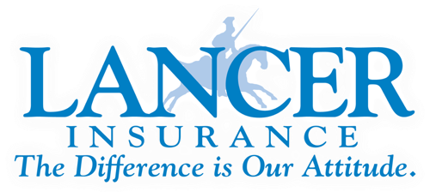

Daniel Tomlinson, Loss Control Manager
Safety and Loss Control Department

I am interested in retaining the position for the Insurance Representative Position on the BISC Executive Committee. I have more than 25 years experience in the field of safety as it relates to commercial transportation. I currently serve on the UMA Risk Management Committee as well as the BISC Executive Committee though the ABA as the Insurance Representative. I have chaired the Government Activities Review Committee with the Bus Industry Safety Council as well. I would like to continue to serve in this role so that I can continue to work with industry members as well as regulatory officials to further improve the safety, compliance, and success of the motorcoach industry and I would ask for your vote.

Thank you.

Previous Experience:

1997-2015
Indian Trails Motorcoach:
-Driver
-Operations Manager
-Facility Manager
-Director of Safety and Training

2015-2016
Trinity Transportation
-Director of Safety and Training

2016-Present
Lancer Insurance Company
-Regional Manager
-Regional Manager Training Specialist/Territory Manager
-Loss Control Manager (2023-present)

Experience includes driving, dispatching, driver training, accident investigation, as well as management positions in logistics and operations, over the road and workplace security, and safety management controls. I have served on several National Safety Councils including the IMG Safety Committee, The Transportation Committee for the National Safety Council, and the Executive Committee for ABA’s Bus Industry Safety Council. I have given many presentations related to safety and compliance at various industry association meetings including the United Motorcoach Association. I have spent time working on committees and various projects with the FMCSA, DHS, and TSA and currently serve on the Board of Directors for the Midwest Bus & Motorcoach Association.

