Transportation professionals,

This special Intercity Bus E-News bulletin is being sent to draw attention to the severity of the situation now facing our country’s motor coach lines. Since our last E-News dispatch, a wave of shutdowns has rocked the sector. An example: Coach USA is permanently closing Lakefront Lines, the largest bus company in the state of Ohio, which alone will eliminate 339 jobs. New Jersey’s DeCamp Bus Lines, which typically carried about 3,000 people per day before the pandemic hit, mostly on charters, is suspending all service tomorrow.

Bus lines are being delivered a one-two punch. First, the modest rebound enjoyed in June has stalled. According to Polina Raygorodskaya, CEO of Wanderu, a leading ground-travel metasearch platform, the demand for bus-ticket purchases in July was still less than 20% of that during that same month in 2019 (see Figure 1 below). The demand for charters appears to have dropped by an even greater extent.
Second, the value of equipment has taken a nosedive, leaving balance sheets in precarious shape and making borrowing more difficult. Unfortunately, loans offered through the CARES Act, which might have closed the gap, have been so restrictive that many carriers opted not to pursue them.
Our assessment, informed by research provided by the American Bus Association, indicates that, 30-40% of the national bus network could disappear without financial relief. Underserved populations, including people of color, people with disabilities, rural communities and older Americans, would be cut off from their most affordable source of mobility and prevented from participating fully in the economy. We are staring at that possibility, perhaps only a few weeks away.
Having discussed the situation with several industry leaders, including Peter Pantuso, President and CEO of ABA, it has become clear that a coordinated governmental response is needed. The gap the federal aid provided to public transit, airports, and air carriers and that provided to motor coach operators needs to be closed to avoid large-scale closures.
Relief will require assistance on multiple fronts but must include aid in next federal stimulus bill, which is now being formulated. What happens on Capitol Hill is impossible to predict, so we are stepping up our outreach to policymakers. We hope you do the same, helping spread the word about the sector’s worsening situation.
Many jobs hang in the balance. Research prepared by Dunham & Associates for ABA indicates that without a strong recovery (and without governmental financial relief), 78% of jobs in the charter-bus sector will be lost during the next year and around 65% will be lost in the commuter, scheduled, and shuttle-bus sectors.

Please scroll down for newly available data provided to us from provided to us by Terry Cordell of Transcor Data Services and Wanderu. You will also find details on the service cutbacks and issues around the country, organized by region. We thank Brian and these companies for obtaining and providing this information, disturbing though the latest results may be.

Stay safe,

﻿Joe Schwieterman
Professor and Director
Chaddick Institute at DePaul University

Figure 1 – US Market Demand for Bus Travel (Source: Wanderu.com)
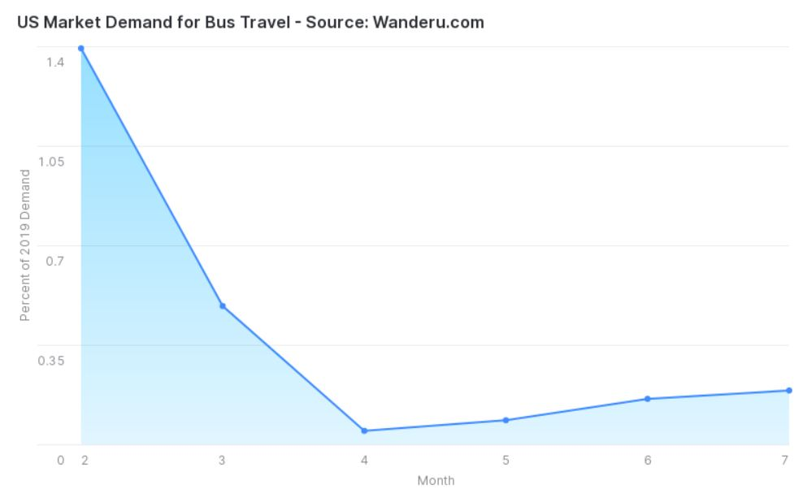
February -------------------------------------------------------------------------------------------------------------> July
Figure 1: Market Demand for Scheduled Bus Service in the U.S. This chart shows a year-over-year comparison of aggregate monthly bus passenger sales sold on Wanderu.com for services throughout the country from February to July 2020 as a percentage of 2019 bus passenger ticket sales sold during those same periods (Y axis).
Credit: Wanderu.com, Polina Raygorodskaya, CEO, via email communication on August 6, 2020

