Wondering whether marijuana is legal in your state?
Last Updated: May 2019
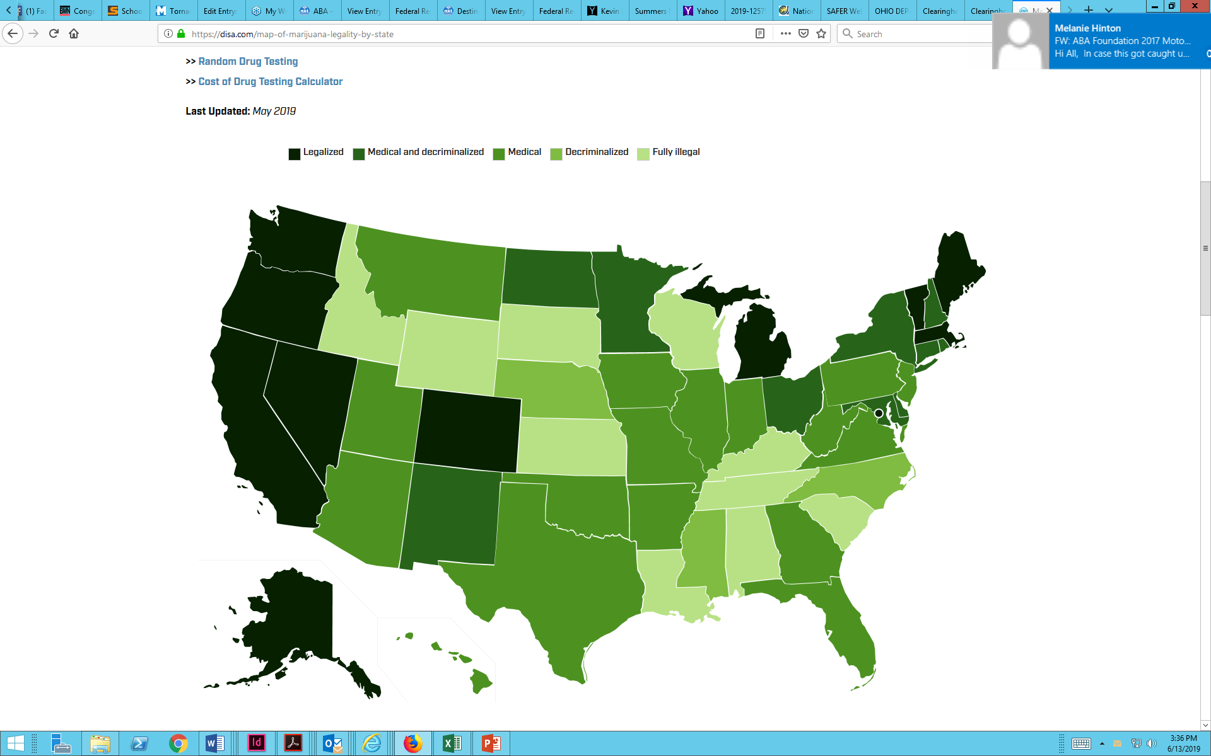

State | Legal Status | Medicinal | Decriminalized | State Laws
Alabama | Fully Illegal | No | No | View State Laws
Alaska | Fully Legal | Yes | Yes | View State Laws
Arizona | Mixed | Yes | No | View State Laws
Arkansas | Mixed | Yes | No | View State Laws
California | Fully Legal | Yes | Yes | View State Laws
Colorado | Fully Legal | Yes | Yes | View State Laws
Connecticut | Mixed | Yes | Reduced | View State Laws
Delaware | Mixed | Yes | Reduced | View State Laws
District of Columbia | Fully Legal | Yes | Yes | View State Laws
Florida | Mixed | Yes | No | View State Laws
Georgia | Mixed | CBD Oil | No | View State Laws
Hawaii | Mixed | Yes | No | View State Laws
Idaho | Fully Illegal | No | No | View State Laws
Illinois | Mixed | Yes | Reduced | View State Laws
Indiana | Mixed | CBD Oil | No | View State Laws
Iowa | Mixed | CBD Oil | No | View State Laws
Kansas | Fully Illegal | No | No | View State Laws
Kentucky | Fully Illegal | No | No | View State Laws
Louisiana | Mixed | Yes | No | View State Laws
Maine | Fully Legal | Yes | Yes | View State Laws
Maryland | Mixed | Yes | Reduced | View State Laws
Massachusetts | Fully Legal | Yes | Yes | View State Laws
Michigan | Fully Legal | Yes | Yes | View State Laws
Minnesota | Mixed | Yes | Reduced | View State Laws
Mississippi | Fully Illegal | No | Reduced | View State Laws
Missouri | Mixed | Yes | Reduced | View State Laws
Montana | Mixed | Yes | No | View State Laws
Nebraska | Fully Illegal | No | Reduced | View State Laws
Nevada | Fully Legal | Yes | Yes | View State Laws
New Hampshire | Mixed | Yes | Reduced | View State Laws
New Jersey | Mixed | Yes | No | View State Laws
New Mexico | Mixed | Yes | Reduced | View State Laws
New York | Mixed | Yes | Reduced | View State Laws
North Carolina | Fully Illegal | No | Reduced | View State Laws
North Dakota | Mixed | Yes | Reduced | View State Laws
Ohio | Mixed | Yes | Reduced | View State Laws
Oklahoma | Mixed | Yes | No | View State Laws
Oregon | Fully Legal | Yes | Yes | View State Laws
Pennsylvania | Mixed | Yes | No | View State Laws
Rhode Island | Mixed | Yes | Reduced | View State Laws
South Carolina | Fully Illegal | No | No | View State Laws
South Dakota | Fully Illegal | No | No | View State Laws
Tennessee | Fully Illegal | No | No | View State Laws
Texas | Mixed | CBD Oil | No | View State Laws
Utah | Mixed | Yes | No | View State Laws
Vermont | Fully Legal | Yes | Yes | View State Laws
Virginia | Mixed | CBD Oil | No | View State Laws
Washington | Fully Legal | Yes | Yes | View State Laws
West Virginia | Mixed | Yes | No | View State Laws
Wisconsin | Fully Illegal | No | No | View State Laws
Wyoming | Fully Illegal | No | No | View State Laws

